### Short Answer Type Questions

**1. If the radius of a circle is 4.2 cm, compute its area and circumference.**

2. What is the area of a circle whose circumference is 44 cm?

3. Calculate the area of a sector of angle 60°. Given, the circle is having a radius of 6 cm.

4. A chord subtends an angle of 90°at the centre of a circle whose radius is 20 cm. Compute the area of the corresponding major segment of the circle.

5. A square is inscribed in a circle. Calculate the ratio of the area of the circle and the square.

6. Find the area of the sector of a circle with radius 4cm and of angle 30°. Also, find the area of the corresponding major sector.

7. Calculate the perimeter of an equilateral triangle if it inscribes a circle whose area is 154 cm2

### Long Answer Type Questions

**Q.1:** **The cost of fencing a circular field at the rate of Rs. 24 per metre is Rs. 5280. The field is to be ploughed at the rate of Rs. 0.50 per m2. Find the cost of ploughing the field (Take π = 22/7).**

Q.2: The wheels of a car are of diameter 80 cm each. How many complete revolutions does each wheel make in 10 minutes when the car is travelling at a speed of 66 km per hour?

Q.3: Find the area of the sector of a circle with radius 4 cm and of angle 30°. Also, find the area of the corresponding major sector (Use π = 3.14)

Q.4: Find the area of the segment AYB shown in the figure, if the radius of the circle is 21 cm and ∠ AOB = 120°. (Use π = 22/7).

Q.5: Find the area of the shaded design in given figure, where ABCD is a square of side 10 cm and semicircles are drawn with each side of the square as diameter. (Use π = 3.14)

. 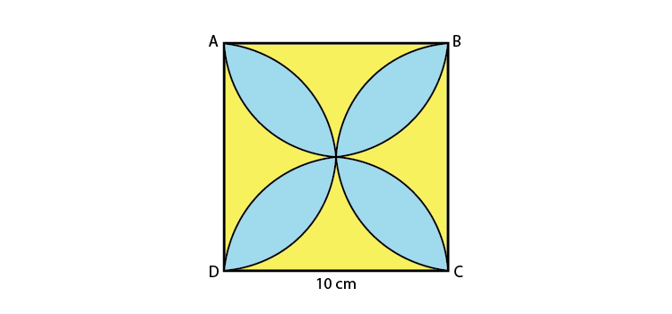

**Q.6: A round table cover has six equal designs as shown in the figure. If the radius of the cover is 28 cm, find the cost of making the designs at the rate of Rs. 0.35 per cm2. (Use 3 = 1.7)**

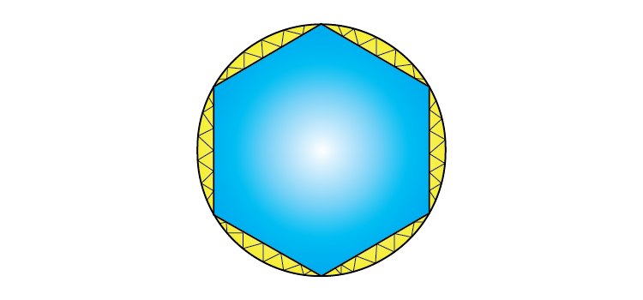

**Q.7: In the figure, AB and CD are two diameters of a circle (with centre O) perpendicular to each other and OD is the diameter of the smaller circle. If OA = 7 cm, find the area of the shaded region.**

**Q.8: Area of the largest triangle that can be inscribed in a semi-circle of radius r units is**

**(A) r2 sq. units (B) ½ r2 sq. units**

**(C) 2 r2 sq. units (D) √2 r2 sq. units**

### Practice Questions For Class 10 Maths Chapter 12 Areas Related to Circles

1. A calf is tied with a rope of length 6 m at the corner of a square grassy lawn of side 20 m. If the length of the rope is increased by 5.5m, find the increase in the area of the grassy lawn in which the calf can graze.
2. Find the radius of a circle whose circumference is equal to the sum of the circumferences of two circles of radii 15 cm and 18 cm.

Find the area of the minor segment of a circle of radius 14 cm, when the angle of the corresponding sector is 60°.

1. If the difference between the circumference and the radius of a circle is 37 cm, then using π = 22/7, calculate the circumference (in cm) of the circle.
2. The length of the minute hand of a clock is 14 cm. Find the area swept by the minute hand in 5 minutes.